***1. Name of employee work in dept_no, with job_id use last_name columns***

use hr;

select department_id, job_id, last_name from employees;

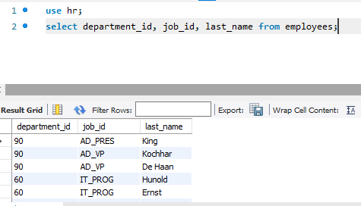

***2. Employees who joined in the year 2000.***

use hr;

select first_name, last_name,hire_date from employees where date_format(hire_date,'%Y')=2000;

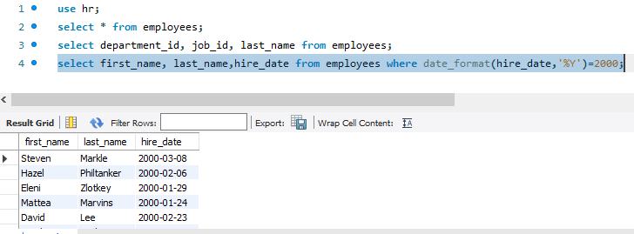

***3. Employees who joined in after Jan_1996***

select employee_id, last_name, hire_date,date_format(hire_date, "%b") from employees where date_format(hire_date,"%M %Y")>='Jan 1996';

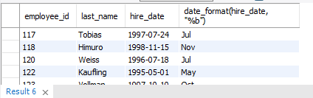

***4. Name starts with S to R***

select concat(first_name," " ,last_name) from employees where first_name like 'S%r' or last_name like 'S%r';

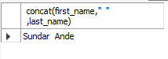

***5. Works under manager_id(500,501)***

select * from employees where (manager_id=200 or manager_id=201);

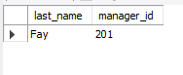

***6. Employees who are "REP" or "MAN" who are paid more than 6000***

select last_name,job_id,salary from employees where ((job_id='SA_REP') OR (job_id='AD_REP') AND (salary>6000));

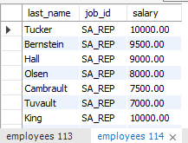

***7. Calculate the annual salary of employee and print them in descending order***

select employee_id, (salary*12)annual_salary from employees order by annual_salary desc;

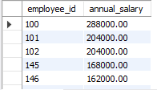

***8. Replace the last_name of "Landry" to "Joe" in the Employee table.***

select replace(last_name,'Landry','Joe') from employees where last_name='Landry';

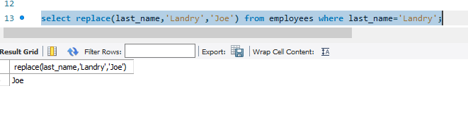

***9. Find the position of first occurrence of the character 'o' in the last name of all employees.***

*select last_name, locate('o',last_name) from employees;*

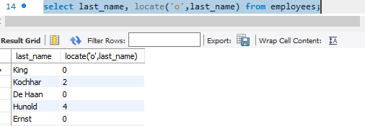

***10. Prefix "2020_B84" for employee last_name who works in department_id=90***

*select employee_id, department_id, last_name, concat("2020_B84",last_name)new_last_name from employees where department_id=90;*

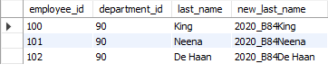

***11. Find the current date with local date and time***

select now();

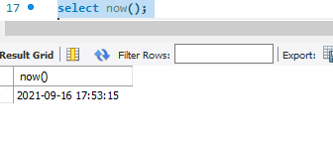

***12. Find the average commission of all employees (ignoring the NULL entries)***

select employee_id,avg(commission_pct) from employees group by employee_id;

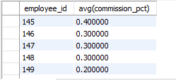

***13. Find the average and highest salary paid for the department 80,90,100***

select department_id, avg(salary), max(salary) from employees where department_id >= 80 and department_id <= 100 group by department_id;

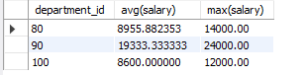

**14. Find the department_id where the highest paid employee salary is more than 1000.**

select department_id, max(salary) from employees group by department_id having max(salary) > 1000

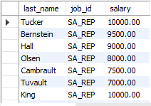

**15. Department ID who is paying the maximum salary in the organization**

SELECT max(sal) FROM (SELECT AVG(salary) sal FROM employees GROUP BY department_id ) AS result;

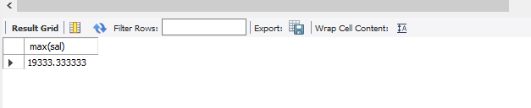

**16. Find the department_name and location_id in which the "Ernst " work**

select department_name, location_id from departments where department_id=(select department_id from employees where last_name="Ernst");



**18. Find the maximum paid salary in the organization**

select employee_id, first_name, last_name from employees where salary=(select max(salary) from employees)

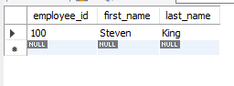

***19. Employees who are drawing minimum salaries from their respective departments***

SELECT employee_id, first_name, last_name, salary, department_id

FROM employees WHERE salary IN (SELECT min(salary) FROM employees

GROUP BY department_id);

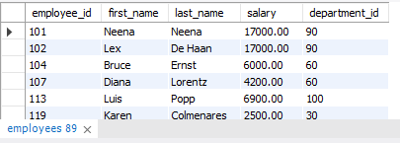

***20. Employees names, Job_id, Job_title by joining employee and jobs table***

SELECT employees.first_name, employees.last_name, employees.job_id, jobs.job_title from employees INNER JOIN jobs ON employees.job_id = jobs.job_id;

